Mobile Application Development
Lab 8

Department of Information Engineering Technology The Superior University, Lahore

Mobile Application Development Lab

Experiment No.8

Navigator, Hero Animation, BottomNavBar
Prepared for

Eisha Nawaz

By:
Name:

ID:

Section:

Semester:

Total Marks: 10

Obtained Marks:

Signature:

Date:

Mobile Application Development
Lab 8

Experiment No.8

Navigator, Hero Animation, BottomNavBar
(Rubrics)

Name: Roll No:
- PSYCHOMOTOR

Sr.  No. | Criteria | Allocated Marks | Unacceptable  0% | Poor  25% | Fair  50% | Good  75% | Excellent  100% | Total Obtained
1 | Follow Procedures | 1 | 0 | 0.25 | 0.5 | 0.75 | 1
2 | Software and Simulations | 2 | 0 | 0.5 | 1 | 1.5 | 2
3 | Accuracy in Output Results | 3 | 0 | 0.75 | 1.5 | 2.25 | 3
Sub Total |  | 6 | Sub Total marks Obtained in Psychomotor(P)

- AFFECTIVE

Sr.  No. | Criteria | Allocated Marks | Unacceptable  0% | Poor  25% | Fair  50% | Good  75% | Excellent  100% | Total Obtained
1 | Respond to Questions | 1 | 0 | 0.25 | 0.5 | 0.75 | 1
2 | Lab Report | 1 | 0 | 0.25 | 0.5 | 0.75 | 1
3 | Assigned Task | 2 | 0 | 0.5 | 1 | 1.5 | 2
Sub Total |  | 4 | Sub Total marks Obtained in Affective (A)

Instructor Name: Eisha Nawaz Total Marks (P+A): 10

Instructor Signature: Obtained Marks (P+A):

Navigator, Hero Animation, BottomNavBar

1.1 Objectives:
The objective of this lab is to master the widgets of flutter and to learn how to use it.

1.2 Overview:
This lab is designed to teach the skills needed to become proficient with the primary framework: flutter.

1.3 Materials and Equipment
• A lab PC or laptop
• Flutter framework

Animation while navigating to different pages is also important if it helps to convey an action, rather than simply being a distraction. What does this mean? Just because you can show fancy animations does not mean you should. Use animations to enhance the UX, not frustrate the user.

USING THE NAVIGATOR
The Navigator widget manages a stack of routes to move between pages. You can optionally pass data to the destination page and back to the original page. To start navigating between pages, you use the Navigator.push, pushNamed, and pop methods. (You’ll learn how to use the pushNamed method in the “Using the Named Navigator Route” section of this chapter.) Navigator is incredibly smart; it shows native navigation on iOS or Android. For example, in iOS when navigating to a new page, you usually slide the next page from the right side of the screen toward the left. In Android when navigat- ing to a new page, you typically slide the next page from the bottom of the screen toward the top. To summarize, in iOS, the new page slides in from the right, and in Android, it slides in from the bottom.
The following example shows you how to use the Navigator.push method to navigate to the About page. The push method passes the BuildContext and Route arguments. To push a new Route argument, you create an instance of the MaterialPageRoute class that replaces the screen with the appropriate platform (iOS or Android) animation transition. In the example, the
fullscreenDialog property is set to true to present the About page as a full-screen modal dialog. By setting the fullscreenDialog property to true, the About page app bar automatically includes a close button. In iOS, the modal dialog transition presents the page by sliding from the bottom of the screen toward the top, and this is also the default for Android.
Navigator.push( context, MaterialPageRoute(
fullscreenDialog: true, builder: (context) => About(),
),
);
The following example shows how to use the Navigator.pop method to close the page and navigate back to the previous page. You call the Navigator.pop(context) method by passing the BuildContext argument, and the page closes by sliding from the top of the screen toward the bot- tom. The second example shows how to pass a value back to the previous page.

// Close page Navigator.pop(context);

// Close page and pass a value back to previous page Navigator.pop(context, 'Done');

TRY IT OUT Creating the Navigator App, Part 1—The About Page
The project has a main home page with a FloatingActionButton to navigate to a gratitude page by passing a default selected Radio button value. The gratitude page shows three Radio buttons to select a value and then pass it back to the home page and update the Text widget with the appropriate value The AppBar has an actions IconButton that navigates to the about page by passing a fullscreenDi­ alog argument set to true to create a full-screen modal dialog. The modal dialog shows a close button at the upper left of the page and animates from the bottom. In this first part, you’ll develop the naviga- tion from the main page to the About page and back.
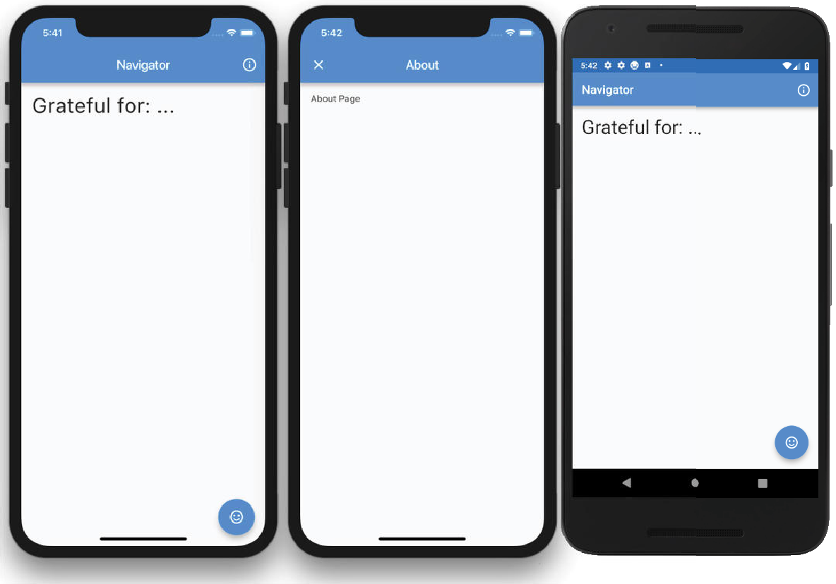

- Create a new Flutter project and name it ch8_navigator. Refer to the instructions in Chapter 4, “Creating a Starter Project Template.” For this project, you need to create only the pages folder.
- Open the home.dart file and add an IconButton to the AppBar actions Widget list.
The IconButton onPressed property will call the method _openPageAbout() and pass context and fullscreenDialog arguments. Do not worry about the squiggly red lines under the method name; you’ll create that method in later steps. The context argument is needed by the Navigator widget, and the fullscreenDialog argument is set to true to show the About page as a full- screen modal. If you set the fullscreenDialog argument to false, the About page shows a back arrow instead of a close button icon.

appBar: AppBar(
title: Text('Navigator'), actions: <Widget>[
IconButton(
icon: Icon(Icons.info_outline),
onPressed: () => _openPageAbout( context: context, fullscreenDialog: true,
),
),
],
),

- Add a SafeArea with Padding as a child to the body.
body: SafeArea( child: Padding(),
),

- In the Padding child, add a Text() widget, with the text 'Grateful for: $_howAreYou'. Notice the $_howAreYou variable, which will contain the returned value when navigating back (Navigator.pop) from the gratitude page. Add a TextStyle class with a fontSize value of
32.0 pixels.
body: SafeArea( child: Padding(
padding: EdgeInsets.all(16.0),
child: Text('Grateful for: $_howAreYou', style: TextStyle(fontSize: 32.0),),
),
),

- To the Scaffold floatingActionButton property, add a FloatingActionButton() widget with an onPressed that calls the method _openPageGratitude(context: context), which passes the context argument.
- For the FloatingActionButton() child, add the icon called sentiment_satisfied, and for the
tooltip, add the 'About' description.
floatingActionButton: FloatingActionButton(
onPressed: () => _openPageGratitude(context: context), tooltip: 'About',
child: Icon(Icons.sentiment_satisfied),
),

- On the first line after the _HomeState class definition, add a String variable called _howAreYou
with a default value of '...'.
String _howAreYou = "...";
- Continue by adding the _openPageAbout() method that accepts BuildContext and bool named parameters with the default values set to false.
void _openPageAbout({BuildContext context, bool fullscreenDialog = false}) {}
- In the openPageAbout() method, add a Navigator.push() method with a context and a second argument of MaterialPageRoute().The MaterialPageRoute() class passes the fullscreen­ Dialog argument and a builder that calls the About() page that you’ll create in later steps.
void _openPageAbout({BuildContext context, bool fullscreenDialog = false}) { Navigator.push(

context, MaterialPageRoute(
fullscreenDialog: fullscreenDialog, builder: (context) => About(),
),
);
}
- On top of the home.dart page, import the about.dart page that you’ll create next.
import 'about.dart';
Navigator is simple to use but also powerful. Let’s examine how it works. Navigator.push() passes two arguments: context and MaterialPageRoute. For the first argument, you pass the context argu- ment. The second argument, MaterialPageRoute(), gives you the horsepower to navigate to another page using platform-specific animation. Only the builder is required to navigate with the optional fullscreenDialog argument.
- Create a new file called about.dart in the lib/pages folder. Since this page only displays infor- mation, create a StatelessWidget class called About.
- For the body, add the usual SafeArea with Padding and the child property as a Text widget.

// about.dart
import 'package:flutter/material.dart';

class About extends StatelessWidget { @override
Widget build(BuildContext context) { return Scaffold(
appBar: AppBar(
title: Text('About'),
),
body: SafeArea( child: Padding(
padding: const EdgeInsets.all(16.0), child: Text('About Page'),
),
),
);
}
}
How It Works
You add to the AppBar an IconButton under the actions property. The icon property for the Icon­ Button is set to Icons.info_outline, the _openPageAbout() method passes the context, and the fullscreenDialog argument is set to true. You also add to the Scaffold a FloatingActionButton that calls the _openPageGratitude() method. The _openPageAbout() method uses the Navigator. push() method to pass the context and the MaterialPageRoute. The MaterialPageRoute passes the fullscreenDialog argument set to true, and the builder calls the About() page. The About page class is a StatelessWidget with a Scaffold and AppBar; the body property has a SafeArea with Padding as a child that shows a Text widget with the “About Page” text.

TRY IT OUT Creating the Navigator App, Part 2—The Gratitude Page
The second part of the app is to navigate to the gratitude page by passing a default value to select the appropriate Radio button. Once you navigate back to the home page, the newly selected Radio button value is passed back and displayed in the Text widget.
- Open the home.dart file, and after the _openPageAbout() method, add the _openPage­ Gratitude() method. The _openPageGratitude() method takes two parameters: a context and a fullscreenDialog bool variable with a default value of false. In this case, the gratitude page is not a fullscreenDialog. Like the previous MaterialPageRoute, the builder opens the page. In this case, it is the gratitude page.
Note that when passing data to the gratitude page and waiting to receive a response, the method is marked as async to wait a response from Navigator.push by using the await keyword.
void _openPageGratitude(
{BuildContext context, bool fullscreenDialog = false}) async { final String _gratitudeResponse = await Navigator.push(
The MaterialPageRoute builder builds the contents of the route. In this case, the content is the gratitude page, which accepts a radioGroupValue int parameter with a value of −1. The −1 value tells the Gratitude class page not to select any Radio buttons. If you pass a value like 2, it selects the appropriate Radio button that corresponds to this value.

builder: (context) => Gratitude( radioGroupValue: ­1,
),
Once the user dismisses the gratitude page, the _gratitudeResponse variable is populated. Use the ?? (double question marks if null) operator to check the _gratitudeResponse for a valid value (not null) and populate the _howAreYou variable. The Text widget is populated with the
_howAreYou value on the home page with the appropriate selected gratitude value or an empty string. In other words, if the _gratitudeResponse value is not null the _howAreYou variable is populated with the_gratitudeResponse value; otherwise the _howAreYou variable is populated by an empty string.
_howAreYou = _gratitudeResponse ?? '';
Here’s the full _openPageGratitude() method code:

void _openPageGratitude(
{BuildContext context, bool fullscreenDialog = false}) async { final String _gratitudeResponse = await Navigator.push(
context, MaterialPageRoute(
fullscreenDialog: fullscreenDialog, builder: (context) => Gratitude(
radioGroupValue: ­1,
),

),
);
_howAreYou = _gratitudeResponse ?? '';
}
- At the top of the home.dart page, add the gratitude.dart page that you’ll create next.
import 'gratitude.dart';
- Create a new file named gratitude.dart in the lib/pages folder. Since this page will modify data (state), create a StatefulWidget class called Gratitude.
To receive data passed from the home page, modify the Gratitude class by adding a final int variable named radioGroupValue. Note the final variable does not start with an underscore. Cre- ate a named constructor requiring this parameter. The radioGroupValue variable is accessed by the class _GratitudeState extends State<Gratitude> by calling widget.radioGroupValue.

class Gratitude extends StatefulWidget { final int radioGroupValue;

Gratitude({Key key, @required this.radioGroupValue}) : super(key: key);

@override
_GratitudeState createState() => _GratitudeState();
}

- For the Scaffold AppBar, add an IconButton to the actions list of Widget. Set the IconButton icon to Icons.check with the onPressed property calling the Navigator.pop, which returns the
_selectedGratitude to the home page.
appBar: AppBar(
title: Text('Gratitude'), actions: <Widget>[
IconButton(
icon: Icon(Icons.check),
onPressed: () => Navigator.pop(context, _selectedGratitude),
),
],
),

- For the body, add the usual SafeArea and Padding with child property as a Row.
The Row children list of Widget contains three alternating Radio and Text widgets. The Radio widget takes the value, groupValue, and onChanged properties. The value property is the ID value for the Radio button. The groupValue property holds the value of the currently selected Radio button. The onChanged passes the selected index value to the custom method _radio­ OnChanged() that handles which Radio button is currently selected. Following each Radio button, there is a Text widget that acts as a label for the Radio button.

Here’s the full body source code:

body: SafeArea( child: Padding(
padding: const EdgeInsets.all(16.0), child: Row(
children: <Widget>[ Radio(
value: 0,
groupValue: _radioGroupValue,
onChanged: (index) => _radioOnChanged(index),
),
Text('Family'), Radio(
value: 1,
groupValue: _radioGroupValue,
onChanged: (index) => _radioOnChanged(index),
),
Text('Friends'), Radio(
value: 2,
groupValue: _radioGroupValue,
onChanged: (index) => _radioOnChanged(index),
),
Text('Coffee'),
],
),
),
),

- On the first line after the _HomeState class definition, add three variables—_gratitudeList,
_selectedGratitude, and _radioGroupValue—and the _radioOnChanged() method.
➤ _gratitudeList is a List of String values.
List<String> _gratitudeList = List();
➤ _selectedGratitude is a String variable containing the selected Radio button value.
String _selectedGratitude;
➤ _radioGroupValue is an int containing the ID of the selected Radio button value. int _radioGroupValue;
- Create the _radioOnChanged() method taking an int for the selected index of the Radio button. In the method, call setState() to have the Radio widgets update with the selected value. The
_radioGroupValue variable is updated with the index. The _selectedGratitude variable (example value Coffee) is updated by taking the _gratitudeList[index] list value by the selected index (position in the list).
void _radioOnChanged(int index) { setState(() {
_radioGroupValue = index;
_selectedGratitude = _gratitudeList[index]; print('_selectedRadioValue $_selectedGratitude');
});
}

- Override initState() to initialize the _gratitudeList. Since the _radioGroupValue is passed from the home page, initialize it with widget.radioGroupValue, which is the final variable passed from the home page.
_gratitudeList..add('Family')..add('Friends')..add('Coffee');
_radioGroupValue = widget.radioGroupValue;
The following is the code that declares all variables and methods:

class _GratitudeState extends State<Gratitude> { List<String> _gratitudeList = List();
String _selectedGratitude; int _radioGroupValue;

void _radioOnChanged(int index) { setState(() {
_radioGroupValue = index;
_selectedGratitude = _gratitudeList[index]; print('_selectedRadioValue $_selectedGratitude');
});
}

@override
void initState() { super.initState();

_gratitudeList..add('Family')..add('Friends')..add('Coffee');
_radioGroupValue = widget.radioGroupValue;
}
Here’s the entire gratitude.dart file source code:
import 'package:flutter/material.dart'; class Gratitude extends StatefulWidget {
final int radioGroupValue;

Gratitude({Key key, @required this.radioGroupValue}) : super(key: key);

@override
_GratitudeState createState() => _GratitudeState();
}

class _GratitudeState extends State<Gratitude> { List<String> _gratitudeList = List();
String _selectedGratitude; int _radioGroupValue;

void _radioOnChanged(int index) { setState(() {
_radioGroupValue = index;
_selectedGratitude = _gratitudeList[index]; print('_selectedRadioValue $_selectedGratitude');
});
}

@override
void initState() { super.initState();

_gratitudeList..add('Family')..add('Friends')..add('Coffee');
_radioGroupValue = widget.radioGroupValue;
}

@override
Widget build(BuildContext context) { return Scaffold(
appBar: AppBar(
title: Text('Gratitude'), actions: <Widget>[
IconButton(
icon: Icon(Icons.check),
onPressed: () => Navigator.pop(context, _selectedGratitude),
),
],
),
body: SafeArea( child: Padding(
padding: const EdgeInsets.all(16.0), child: Row(
children: <Widget>[ Radio(
value: 0,
groupValue: _radioGroupValue,
onChanged: (index) => _radioOnChanged(index),
),
Text('Family'), Radio(
value: 1,
groupValue: _radioGroupValue,
onChanged: (index) => _radioOnChanged(index),
),
Text('Friends'), Radio(
value: 2,
groupValue: _radioGroupValue,
onChanged: (index) => _radioOnChanged(index),
),
Text('Coffee'),
],
),
),
),
);
}
}

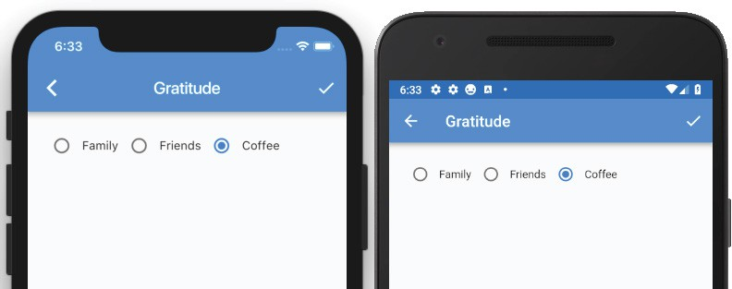

How It Works
You have the entire app created with a home page that can navigate to the about page as a full­ screenDialog. The fullscreenDialog gives the about page a default close action button. By tapping the home page’s FloatingActionButton, the Navigator MaterialPageRoute builder builds the con- tents for the route, in this case the gratitude page. Through the Gratitude constructor, data is passed to unselected Radio buttons. From the gratitude page, a list of Radio buttons gives a choice to select a gratitude. By tapping the AppBar action button (checkbox IconButton), the Navigator.pop method passes the selected gratitude value back to the Home Text widget. From the home page, you called the Navigator.push method by using the await keyword, and the method has been waiting to receive a value. Once the About page’s Navigator.pop method is called, it returns a value to the home page’s
_gratitudeResponse variable. Using the await keyword is a powerful and straightforward feature to implement.
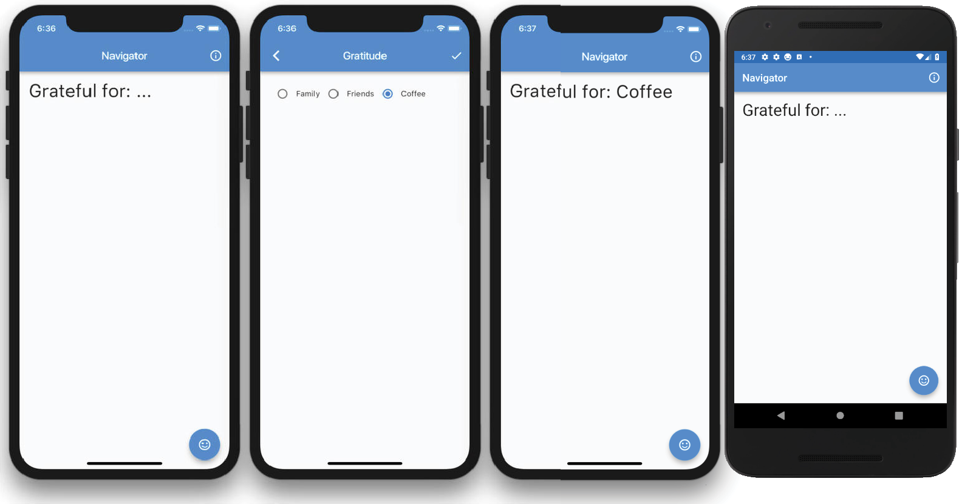

Using the Named Navigator Route
An alternate way to use Navigator is to refer to the page that you are navigating to by the route name. The route name starts with a slash, and then comes the route name. For example, the About page route name is '/about'. The list of routes is built into the MaterialApp() widget. The routes have a Map of String and WidgetBuilder where the String is the route name, and the WidgetBuilder has a builder to build the contents of the route by the Class name (About) of the page to open.

routes: <String, WidgetBuilder>{
'/about': (BuildContext context) => About(), '/gratitude': (BuildContext context) => Gratitude(),
},
To call the route, the Navigator.pushNamed() method is called by passing two arguments. The first argument is context, and the second is the route name.
Navigator.pushNamed(context, '/about');

USING HERO ANIMATION
The Hero widget is a great out-of-the-box animation to convey the navigation action of a widget flying into place from one page to another. The hero animation is a shared element transition (anima- tion) between two different pages.
To visualize the animation, imagine seeing a superhero flying into action. For example, you have a list of journal entries with a photo thumbnail, the user selects an entry, and you see the photo thumbnail transition to the detail page by moving and growing to full size. The photo thumbnail is the super- hero, and when tapped, it flies into action by moving from the list page to the detail page and lands perfectly on the correct location at the top of the detail page showing the full photo. When the detail page is dismissed, the Hero widget flies back to the original page, position, and size. In other words, the animation shows the photo thumbnail moving and growing into place from the list page to the detail page, and once the detail page is dismissed, the animation and size are reversed. The Hero widget has all of these features built in; there’s no need to write custom code to handle the size and animation between pages.
To continue with the previous scenario, you wrap the list page Image widget as a child of the Hero widget and assign a tag property name. Repeat the same steps for the detail page and make sure the tag property value is the same in both pages.

// List page Hero(
tag: 'photo1', child: Image(
image: AssetImage("assets/images/coffee.png"),
),
),

// Detail page Hero(

tag: 'photo1', child: Container(
child: Image(
image: AssetImage("assets/images/coffee.png"),
),
),
),
The Hero child widget is marked for hero animation. When the Navigator pushes or pops a Page­ Route, the entire screen’s content is replaced. This means during the animation transition the Hero widget is not shown in the original position in both the old and new routes, but it moves and resizes from one page to another. Each Hero tag must be unique and match on both the originating and landing pages.

TRY IT OUT Creating the Hero Animation App
In this example, the Hero widget has an Icon as a child wrapped in a GestureDetector. An InkWell could also be used instead of the GestureDetector to show a material tap animation. The InkWell widget is a Material Component that responds to touch gestures by displaying a splash (ripple) effect. You’ll take a more in-depth look at GestureDetector and InkWell in Chapter 11, “Applying Interac- tivity.” When the Icon is tapped, Navigator.push is called to navigate to the detail screen, called Fly. Since the Hero widget animation is like a superhero flying, the detail screen is named Fly.
- Create a new Flutter project and name it ch8_hero_animation. Again, you can follow the instruc- tions in Chapter 4. For this project, you need to create only the pages folder.
- Open the home.dart file and add to the body a SafeArea with Padding as a child. body: SafeArea(
child: Padding(),
),

- In the Padding child, add the GestureDetector() widget, which you will create next.
body: SafeArea( child: Padding(
padding: const EdgeInsets.all(16.0), child: GestureDetector(),
),
),

- Add to the GestureDetector child a Hero widget with tag 'format_paint'; tag can be any unique ID. The Hero widget child is a format_paint icon with lightGreen color and a size value of 120.0 pixels. Note you could have used an InkWell() widget instead of GestureDetector(). The InkWell() widget shows a splash feedback where tapped, but the GestureDetector() widget will not show the touch feedback. For the onTap property, you call Navigator.push to open the detail page called Fly.
GestureDetector( child: Hero(
tag: 'format_paint',

child: Icon( Icons.format_paint, color: Colors.lightGreen, size: 120.0,
),
),
onTap: () { Navigator.push(
context,
MaterialPageRoute(builder: (context) => Fly()),
);
},
),

- At the top of the home.dart page, import the fly.dart page that you will create next.
import 'fly.dart';
Here’s the entire Home.dart file source code:

import 'package:flutter/material.dart'; import 'fly.dart';

class Home extends StatelessWidget { @override
Widget build(BuildContext context) { return Scaffold(
appBar: AppBar(
title: Text('Hero Animation'),
),
body: SafeArea( child: Padding(
padding: EdgeInsets.all(16.0), child: GestureDetector(
child: Hero(
tag: 'format_paint', child: Icon(
Icons.format_paint, color: Colors.lightGreen, size: 120.0,
),
),
onTap: () { Navigator.push(
context,
MaterialPageRoute(builder: (context) => Fly()),
);
},
),
),
),
);
}
}

- Create a new file called fly.dart in the lib/pages folder. Since this page only displays informa- tion, create a StatelessWidget class called Fly. For the body, add the usual SafeArea with a child set to the Hero() widget.
body: SafeArea( child: Hero(),
),

- To calculate the width of the Icon, after Widget build(BuildContext context) {, add a double variable called _width set by MediaQuery.of(context).size.shortestSide / 2. The shortestSide property returns the lesser of the width or height of the screen, and you divide by two to make it half the size.
The reason you calculate the width is only to resize the Icon width according to device size and orientation. If you used an Image instead, this calculation would not be necessary; it can be done by using BoxFit.fitWidth.
double _width = MediaQuery.of(context).size.shortestSide / 2;
- Add to the Hero widget a tag of 'format_paint' with a Container for the child. Note for the Hero widget to work properly, the tag needs to be the same name you gave in the GestureDetector child Hero widget in the home.dart file. The Container child is a format_ paint icon with lightGreen color and a size value of the width variable. For the Container alignment property, use Alignment.bottomCenter. You can experiment using different Alignment values to see the hero animation variations at work.
Hero(
tag: 'format_paint', child: Container(
alignment: Alignment.bottomCenter, child: Icon(
Icons.format_paint, color: Colors.lightGreen, size: _width,
),
),
)
Here’s the entire Fly.dart file source code:
import 'package:flutter/material.dart'; class Fly extends StatelessWidget {
@override
Widget build(BuildContext context) {
double _width = MediaQuery.of(context).size.shortestSide / 2;

return Scaffold( appBar: AppBar(
title: Text('Fly'),
),

body: SafeArea( child: Hero(
tag: 'format_paint', child: Container(
alignment: Alignment.bottomCenter, child: Icon(
Icons.format_paint, color: Colors.lightGreen, size: _width,
),
),
),
),
);
}
}
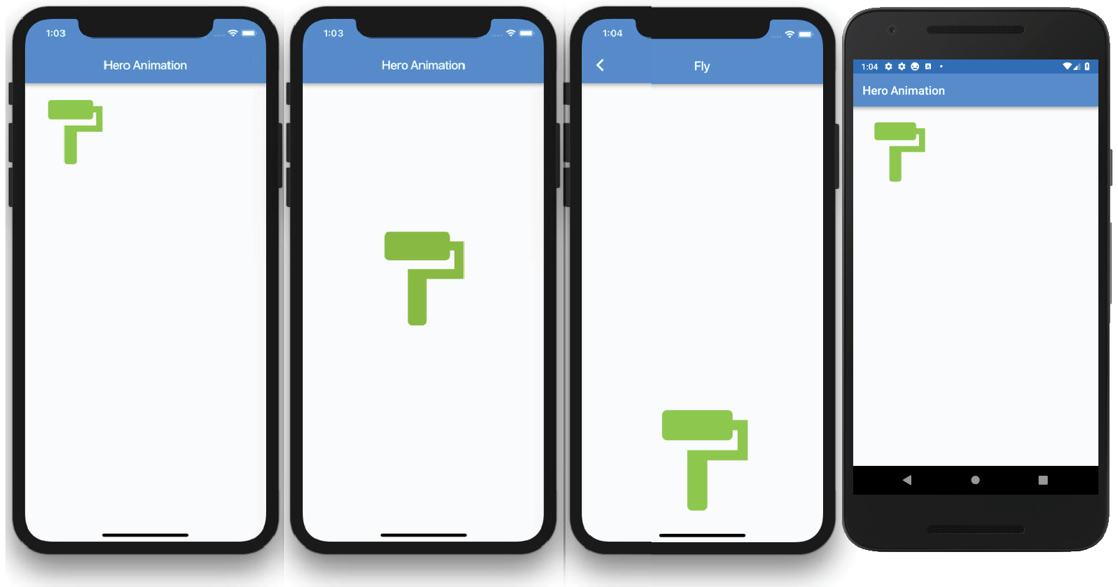

How It Works
The hero animation is a powerful built-in animation to convey an action by automatically animating a widget from one page to another to the correct size and position. On the home page, you declare a GestureDetector with the Hero widget as the child widget. The Hero widget sets an Icon as the child. The onTap calls the Navigator.push() method, which navigates to the page Fly. All you need to do on the Fly page is to declare the widget you’re animating to as a child of the Hero widget. When you navigate back to the home page, the Hero animates the Icon to the original position.

USING THE BOTTOMNAVIGATIONBAR
BottomNavigationBar is a Material Design widget that displays a list of BottomNavigation­ BarItems that contains an icon and a title at the bottom of the page (Figure 8.1). When the BottomNavigationBarItem is selected, the appropriate page is built.
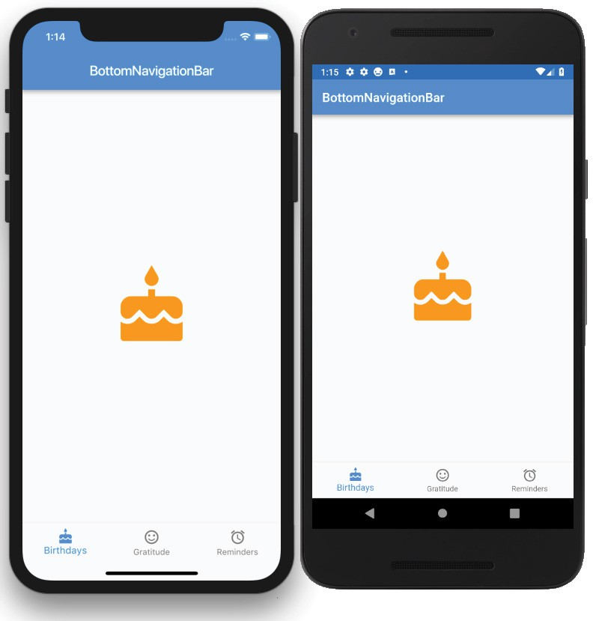
FIGURE 8.1: Final BottomNavigationBar with icons and titles

TRY IT OUT Creating the BottomNavigationBar App
In this example, BottomNavigationBar has three BottomNavigationBarItems that replace the current page with the selected one. There are different ways to display the selected page; you use a Widget class as a variable.

- Create a new Flutter project and name it ch8_bottom_navigation_bar. As always, you can follow the instructions in Chapter 4. For this project, you need to create only the pages folder.
- Open the home.dart file, and add to the body a SafeArea with Padding as a child. body: SafeArea(
child: Padding(),
),

- In the Padding child, add the variable Widget _currentPage, which you will create next. Note this time you are using a Widget class to create the _currentPage variable that holds each page that is selected, either the Gratitude, Reminders, or Birthdays StatelessWidget class.
body: SafeArea( child: Padding(
padding: const EdgeInsets.all(16.0), child: _ currentPage,
),
),

- Add to the Scaffold bottomNavigationBar property a BottomNavigationBar widget. For the
currentIndex property, use the _currentIndex variable, which will be created later.
bottomNavigationBar: BottomNavigationBar( currentIndex: _currentIndex,
The items property is a List of BottomNavigationBarItems. Each BottomNavigationBarItem
takes an icon property and a title property.
- Add to the items property three BottomNavigationBarItems with icon cake, sentiment_satisfied, and access_alarm. The titles are 'Birthdays', 'Gratitude', and 'Reminders'.
items: [ BottomNavigationBarItem(
icon: Icon(Icons.cake), title: Text('Birthdays'),
),

- For the onTap property, the callback returns the current index of the active item. Name the variable selectedIndex.
onTap: (selectedIndex) => _changePage(selectedIndex),
Here’s the entire BottomNavigationBar code:

bottomNavigationBar: BottomNavigationBar( currentIndex: _currentIndex,
items: [ BottomNavigationBarItem(
icon: Icon(Icons.cake), title: Text('Birthdays'),
),

BottomNavigationBarItem(
icon: Icon(Icons.sentiment_satisfied), title: Text('Gratitude'),
),
BottomNavigationBarItem(
icon: Icon(Icons.access_alarm), title: Text('Reminders'),
),
],
onTap: (selectedIndex) => _changePage(selectedIndex),
),

- Add the _changePage(int selectedIndex) method after Scaffold(). The _changePage() method accepts an int value of the selected index. The selectedIndex is used with the setState() method to set the _currentIndex and _currentPage variables.
The _currentIndex equals the selectedIndex, and the _currentPage equals the page from the
List _listPages that corresponds to the selected index.
It’s important to note that the Widget _currentPage variable displays each page selected without the need for a Navigator widget. This is a great example of the power of customizing widgets to your needs.

void _changePage(int selectedIndex) { setState(() {
_currentIndex = selectedIndex;
_currentPage = _listPages[selectedIndex];
});
}

- On the first line after the _HomeState class definition, add the variables _currentIndex,
_listPages, and _currentPage. The _listPages List holds each page’s Class name.
int _currentIndex = 0; List _listPages = List(); Widget _currentPage;

- Override initState() to add each page to the _listPages List and initialize the _currentPage with the Birthdays() page. Note the use of cascade notation; the double dots allow you to perform a sequence of operations on the same object.
@override
void initState() { super.initState();

_listPages
..add(Birthdays())
..add(Gratitude())
..add(Reminders());
_currentPage = Birthdays();
}

- Add to the top of the home.dart file the imports for each page that will be created next.
import 'package:flutter/material.dart'; import 'gratitude.dart';
import 'reminders.dart'; import 'birthdays.dart';
Here’s the entire home.dart file:

import 'package:flutter/material.dart'; import 'gratitude.dart';
import 'reminders.dart'; import 'birthdays.dart';

class Home extends StatefulWidget { @override
_HomeState createState() => _HomeState();
}

class _HomeState extends State<Home> { int _currentIndex = 0;
List _listPages = List(); Widget _currentPage;

@override
void initState() { super.initState();

_listPages
..add(Birthdays())
..add(Gratitude())
..add(Reminders());
_currentPage = Birthdays();
}

void _changePage(int selectedIndex) { setState(() {
_currentIndex = selectedIndex;
_currentPage = _listPages[selectedIndex];
});
}

@override
Widget build(BuildContext context) { return Scaffold(
appBar: AppBar(
title: Text('BottomNavigationBar'),
),
body: SafeArea( child: Padding(
padding: EdgeInsets.all(16.0), child: _currentPage,
),
),

bottomNavigationBar: BottomNavigationBar( currentIndex: _currentIndex,
items: [ BottomNavigationBarItem(
icon: Icon(Icons.cake), title: Text('Birthdays'),
),
BottomNavigationBarItem(
icon: Icon(Icons.sentiment_satisfied), title: Text('Gratitude'),
),
BottomNavigationBarItem(
icon: Icon(Icons.access_alarm), title: Text('Reminders'),
),
],
onTap: (selectedIndex) => _changePage(selectedIndex),
),
);
}
}
- Create three StatelessWidget pages and call them Birthdays, Gratitude, and Reminders. Each page will have a Scaffold with Center() for the body. The Center child is an Icon with a size value of 120.0 pixels and a color property. Here are the three Dart files, birthdays.dart, gratitude.dart, and reminders.dart:
// birthdays.dart
import 'package:flutter/material.dart';

class Birthdays extends StatelessWidget { @override
Widget build(BuildContext context) { return Scaffold(
body: Center( child: Icon(
Icons.cake, size: 120.0,
color: Colors.orange,
),
),
);
}
}

// gratitude.dart
import 'package:flutter/material.dart';

class Gratitude extends StatelessWidget { @override
Widget build(BuildContext context) { return Scaffold(
body: Center( child: Icon(
Icons.sentiment_satisfied,

size: 120.0,
color: Colors.lightGreen,
),
),
);
}
}

// reminders.dart
import 'package:flutter/material.dart';

class Reminders extends StatelessWidget { @override
Widget build(BuildContext context) { return Scaffold(
body: Center( child: Icon(
Icons.access_alarm, size: 120.0,
color: Colors.purple,
),
),
);
}
}
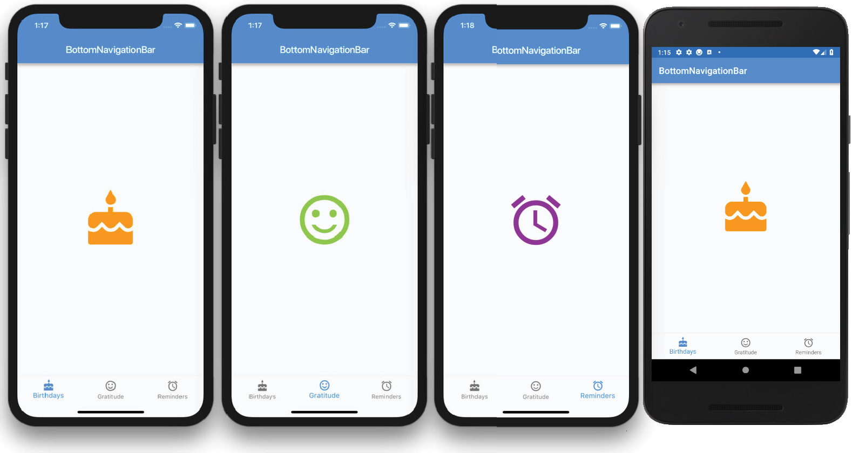

How It Works
The BottomNavigationBar items property has a List of three BottomNavigationBarItems. For each BottomNavigationBarItem, you set an icon property and a title property. The Bottom­

NavigationBar onTap passes the selected index value to the _changePage method. The _changePage method uses setState() to set the _currentIndex and _currentPage to display. The _currentIndex sets the selected BottomNavigationBarItem, and the _currentPage sets the current page to display from the _listPages List.

USING THE BOTTOMAPPBAR
The BottomAppBar widget behaves similarly to the BottomNavigationBar, but it has an optional notch along the top. By adding a FloatingActionButton and enabling the notch, the notch provides a nice 3D effect so it looks like the button is recessed into the
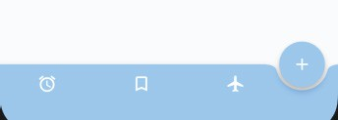
navigation bar (Figure 8.2). For example, to enable the notch, you set the BottomAppBar shape property to a Notched­ Shape class like the CircularNotchedRectangle() class and set the Scaffold floatingActionButtonLocation property to FloatingActionButtonLocation.endDocked or center­

Docked. Add to the Scaffold floatingActionButton prop- erty a FloatingActionButton widget, and the result shows the FloatingActionButton embedded into the BottomApp­ Bar widget, which is the notch.

BottomAppBar(
shape: CircularNotchedRectangle(),
FIGURE 8.2: BottomAppBar with embedded FloatingActionButton creating a notch

)

floatingActionButtonLocation: FloatingActionButtonLocation.endDocked, floatingActionButton: FloatingActionButton(
child: Icon(Icons.add),
),

TRY IT OUT Creating the BottomAppBar App
In this example, the BottomAppBar has a Row as a child with three IconButtons to show selection items. The main objective is to use a FloatingActionButton to dock it to the BottomAppBar with a notch.
The notch is enabled by the BottomAppBar shape property set to CircularNotchedRectangle().
- Create a new Flutter project and name it ch8_bottom_app_bar. Again, you can follow the instruc- tions in Chapter 4. For this project, you only need to create the pages folder.
- Open the home.dart file, and add to the body a SafeArea with a Container as a child. body: SafeArea(
child: Container(),
),

- Add a BottomAppBar() widget to the Scaffold bottomNavigationBar property.
bottomNavigationBar: BottomAppBar(),

- To enable the notch, you set two properties.
➤ First set the BottomAppBar shape property to CircularNotchedRectangle(). Set the
color property to Colors.blue.shade200 and add a Row as a child.
➤ Next set floatingActionButtonLocation, which you will handle in step 7.

bottomNavigationBar: BottomAppBar( color: Colors.blue.shade200, shape: CircularNotchedRectangle(), child: Row(),
),

- Continue by adding to the Row a mainAxisAlignment property as MainAxisAlignment.space­ Around. The spaceAround constant allows the IconButtons to have even spacing between them.
bottomNavigationBar: BottomAppBar( color: Colors.blue.shade200, shape: CircularNotchedRectangle(), child: Row(
mainAxisAlignment: MainAxisAlignment.spaceAround, children: <Widget>[
],
),
),

- Add three IconButtons to the Row children list. After the last IconButton, add a Divider() to add an even space to the right since FloatingActionButton is docked on the right side of the BottomAppBar. Instead of a Divider(), you could have used a Container with a width property.
bottomNavigationBar: BottomAppBar( color: Colors.blue.shade200, shape: CircularNotchedRectangle(), child: Row(
mainAxisAlignment: MainAxisAlignment.spaceAround, children: <Widget>[
IconButton(
icon: Icon(Icons.access_alarm), color: Colors.white,
onPressed: (){},
),
IconButton(
icon: Icon(Icons.bookmark_border), color: Colors.white,
onPressed: (){},
),
IconButton(
icon: Icon(Icons.flight), color: Colors.white, onPressed: (){},
),
Divider(),
],
),
),

- Set the notch location of the floatingActionButtonLocation property to
FloatingActionButtonLocation.endDocked. You could also set it to centerDocked. floatingActionButtonLocation: FloatingActionButtonLocation.endDocked,
- Add a FloatingActionButton to the floatingActionButton property.
floatingActionButton: FloatingActionButton( backgroundColor: Colors.blue.shade200, onPressed: () {},
child: Icon(Icons.add),
),
Here’s the entire home.dart file source code:
import 'package:flutter/material.dart'; class Home extends StatefulWidget {
@override
_HomeState createState() => _HomeState();
}

class _HomeState extends State<Home> { @override
Widget build(BuildContext context) { return Scaffold(
appBar: AppBar(
title: Text('BottomAppBar'),
),
body: SafeArea( child: Container(),
),
bottomNavigationBar: BottomAppBar( color: Colors.blue.shade200, shape: CircularNotchedRectangle(), child: Row(
mainAxisAlignment: MainAxisAlignment.spaceAround, children: <Widget>[
IconButton(
icon: Icon(Icons.access_alarm), color: Colors.white,
onPressed: (){},
),
IconButton(
icon: Icon(Icons.bookmark_border), color: Colors.white,
onPressed: (){},
),
IconButton(
icon: Icon(Icons.flight), color: Colors.white, onPressed: (){},
),
Divider(),
],

),
),
floatingActionButtonLocation: FloatingActionButtonLocation.endDocked, floatingActionButton: FloatingActionButton(
backgroundColor: Colors.blue.shade200, onPressed: () {},
child: Icon(Icons.add),
),
);
}
}
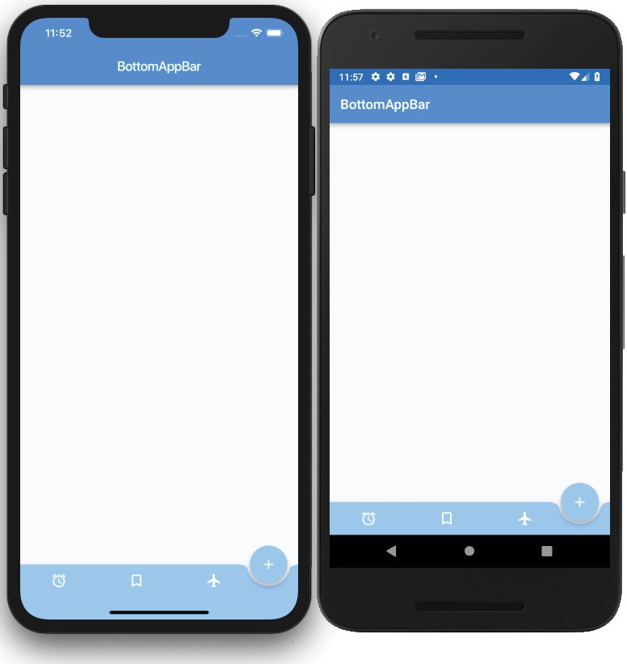

How It Works
To enable the notch, two properties need to be set for the Scaffold widget. The first is to use a BottomAppBar with the shape property set to CircularNotchedRectangle(). The second is to set the floatingActionButtonLocation property to FloatingActionButtonLocation.endDocked or centerDocked.

